RobotC
Activity 3.1.1 Inputs and Outputs – VEX
- Fill in the Table
Motor/Sensor | Directions | Observations  (include threshold power setting for the motor to turn)
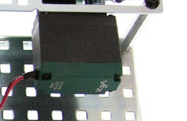  Motor | Enter several values ranging from -127 to 127, then press Enter on the keyboard or click away from the value entry window. | Right | Higher the absolute value of typed in number, higher the speed. – or + determines which way it rotates
 |  | Left | Higher the absolute value of typed in number, higher the speed. – or + determines which way it rotates
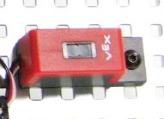  Line Follower | Change the line follower immediate environment and observe the effect on the lineFollower value. Use a dark and light color within 1/4 - 1/8 in. to see the change in the sensor value. | Measures how much light emitted into sensor  Lighter objects higher  Darker objects lower
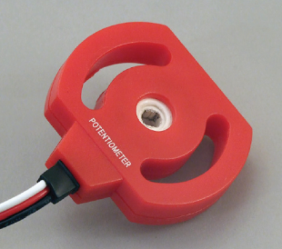  Potentiometer | Change the potentiometer setting and observe the effect on the potentiometer value. Rotate the potentiometer to change the sensor input. Do not force the potentiometer beyond the CW and CCW physical stops.  Calculate the angle change between whole number values in your engineering notebook. Use the protractor below to measure an angle. | Rotates approx. 270 degrees  Measures distance in circular motion
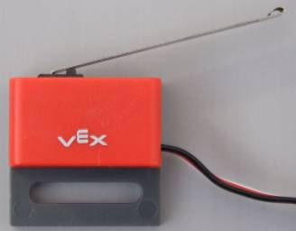  Limit Switch | Change the limit switch environment and observe the effect on the limitSwitch value. | Clicks  On/ clicked in-1  Off/ not clicked- 0
Bumper Switch | Change the bumper switch environment and observe the effect on the bumpSwitch value. | Clicks  On/ clicked in-1  Off/ not clicked- 0
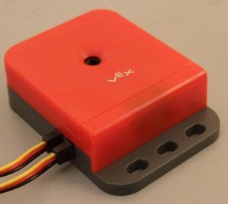  Optical Encoder | Change the optical encoder environment and observe the effect on the quad value. Rotate the optical encoder. Note that there is no CW or CCW physical stop therefore it can be turned indefinitely in a direction. | Turns all the way around  Measures how many degrees, very specific
Green LED | Enter a 0 value, then press Enter on the keyboard or elsewhere in the dialog window. Did the LED respond as you expected?  Enter a 1 value, then press Enter on the keyboard or click away from the value entry window. Did the LED respond as you expected? | Turns on  Is green
Servo Motor | Enter several values ranging from -127 to 127, then press Enter on the keyboard or click away from the value entry window.  Calculate the angle change between whole number values in your engineering notebook. Use the protractor above to measure an angle. | Turns to specific positions  - Or + determines which direction it rotates
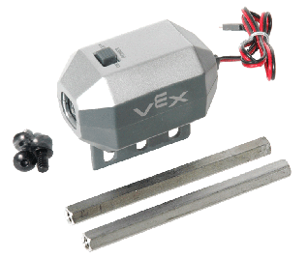  Flashlight | Enter several values ranging from -127 to 127, then press Enter on the keyboard or click away from the value entry window. This allows the value to be updated. Note that the flashlight needs a negative value in the debugger window. | Turns on, provides light
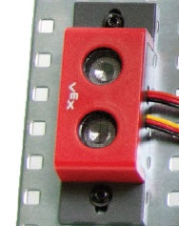  Ultrasonic | Change the ultrasonic environment with a solid object in front of the ultrasonic sensor. Observe the effect on the sonar value. | Measures how far things are away from it  Uses sonar
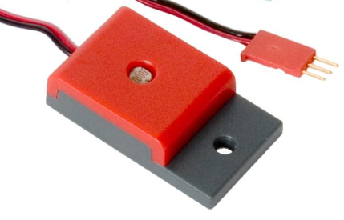  Light Sensor | Change the light sensor’s immediate environment by activating the flashlight and shine it on the light sensor. Use your hand to shield the light to the sensor to change the sensor input. Observe the effect on the lightSensor value. | Works oppositely as line follower, light makes number go down, dark makes it go up  Detects lightness and darkness

